**COUNCIL ASSESSMENT REPORT**

|  |  |
| --- | --- |
| **Panel Reference** | PPS2019HCC023 |
| **DA number** | DA/790/2019 |
| **LGA** | Lake Macquarie City Council |
| **Proposed development** | Recreation facility (indoor and outdoor) – alterations and additions, and Community facility |
| **Street address** | 45 Stockland Drive, Glendale |
| **Applicant/Owner** | Applicant: EJE Architecture  Owner: Lake Macquarie City Council |
| **Date of DA lodgement** | 30 May 2019 |
| **Number of submissions** | Nil |
| **Recommendation** | Approval, subject to conditions of consent |
| **Regional Development Criteria (Schedule 7 of the SEPP (State and Regional Development) 2011** | Council related development over $5 million |
| **List of all relevant s4.15(1)(a) matters** | * State Environmental Planning Policy (State and Regional Development) 2011 * State Environmental Planning Policy No. 55 – Remediation of Land * State Environmental Planning Policy No. 64 – Advertising and Signage * Lake Macquarie Local Environmental Plan 2014 * Lake Macquarie Development Control Plan 2014 |
| **List all documents submitted with this report for the Panel’s consideration** | Attachment A: Draft Conditions of Consent  Attachment B: Architectural Plans  Attachment C: Landscape Plans  Attachment D: Engineering Plans  Attachment E: Clause 4.6 Exception to Development Standard |
| **Clause 4.6 request** | An exception to development standards is requested in relation to the maximum building height set under LMLEP 2014 clause 4.3. |
| **Report prepared by** | Anna Kleinmeulman, Senior Development Planner |
| **Report date** | 22 April 2019 |

|  |  |
| --- | --- |
| **Summary of s4.15 matters**  Have all recommendations in relation to relevant s4.15 matters been summarised in the Executive Summary of the assessment report? | **Yes** |
| **Legislative clauses requiring consent authority satisfaction**  Have relevant clauses in all applicable environmental planning instruments where the consent authority must be satisfied about a particular matter been listed, and relevant recommendations summarized, in the Executive Summary of the assessment report? | **Yes** |
| **Clause 4.6 Exceptions to development standards**  If a written request for a contravention to a development standard (clause 4.6 of the LEP) has been received, has it been attached to the assessment report? | **Yes** |
| **Special Infrastructure Contributions**  Does the DA require Special Infrastructure Contributions conditions (S7.24)? | **No** |
| **Conditions**  Have draft conditions been provided to the applicant for comment? | **Yes** |

**Development Application DA/790/2019**

|  |  |
| --- | --- |
| **Key dates:** | Lodgement: 30 May 2019  Request for information: 18 September 2019  RPP on-site briefing: 4 March 2020  Final plans received: 23 March 2020 |
| **Submission period:** | 6 June to 28 June 2019 |
| **Zoning:** | B3 Commercial Core |
| **Approval bodies:** | Subsidence Advisory NSW  Natural Resource Access Regulator |
| **CIV:** | $35,210,000 |

**Executive summary**

This report assesses the proposal against relevant State, Regional and Local Environmental Planning Instruments and Policies, in accordance with section 4.15(1) of the Environmental Planning and Assessment Act, 1979.

The application seeks consent for alterations and additions to the Hunter Regional Sports Centre and the addition of community facilities.

The application has been assessed against relevant legislation including State Environmental Planning Policy (State and Regional Development) 2011, State Environmental Planning Policy No. 55 – Remediation of Land, State Environmental Planning Policy No. 64 – Advertising and Signage, Lake Macquarie Local Environmental Plan 2014 (LMLEP)and Lake Macquarie Development Control Plan 2014 (LMDCP). The development is considered to meet the relevant assessment criteria contained within these planning documents.

A submission under clause 4.6 ‘Exceptions to development standards’ of LMLEP 2014 has been submitted in relation to the 13m maximum height limit applicable to the site. The variation is considered worthy of support.

**Reasons for determination**

The development has been assessed against the matters for consideration that apply to the land to which the development application relates as outlined in section 4.15 of the Environmental Planning and Assessment Act, 1979 as follows:

* the development meets the requirements of the LMLEP 2014 and other relevant environmental planning instruments inclusive of a clause 4.6 submission exception to the development standard under clause 4.3 Height of buildings;
* consideration has been given to proposed instruments which have been the subject of public consultation;
* the development generally complies with LMDCP 2014 with any variations to the controls outlined and justified within this assessment report;
* considering the likely impacts of the development on the natural and built environments, the development is considered to provide balanced and appropriate outcomes;
* the suitability of the site for the development, including characteristics and constraints of the land have been considered and it was found the land as being suitable for the development;
* matters of public interest have been taken into account in relation to social, economic and environmental outcomes.

Based on the balance of the matters considered, the development application is recommended for approval.  Details of the assessment are contained in the assessment report below.

**Community interest**

The assessment of the proposed development under section 4.15(1) of the Environmental Planning and Assessment Act, 1979 has considered the community views. The development application was notified in accordance with the Development Notification Requirements outlined in section 1.15 of Part 1 of LMDCP 2014 as adopted by Lake Macquarie City Council.

No submissions were received in response to the public notification of the development. Community views however were taken into consideration with the development being assessed against the provisions of the LMLEP 2014 and LMDCP 2014, both of which have been publicly exhibited and adopted by Lake Macquarie City Council.

**Site and context**

The site has an area of 9.58 hectares and is zoned B3 Commercial Core under LMLEP 2014.

An existing recreation facility (outdoor) and recreation facility (indoor) known as the Hunter Regional Sports Centre currently occupies the site. This facility includes a gymnastics centre and track and field facilities. A childcare centre also operates from the site as a separate entity.

Figure 1 shows the site in relation to surrounding land uses. The site has frontage to Stockland Drive and is bounded by retail development to the south and west known as Stockland Glendale Shopping Centre, mixed commercial and industrial development to the north-west and native bushland to the north and east. Winding Creek runs parallel to the northern boundary.

The topography is relatively flat and with a slight downslope towards Winding Creek to the north.

Site constraints include the following:

* within mine subsidence district;
* flood control lot – high hazard;
* possible site contamination;
* sensitive Aboriginal landscape area; and
* bushfire prone land.

The above matters have been addressed and are not considered to pose significant impediments to the development.

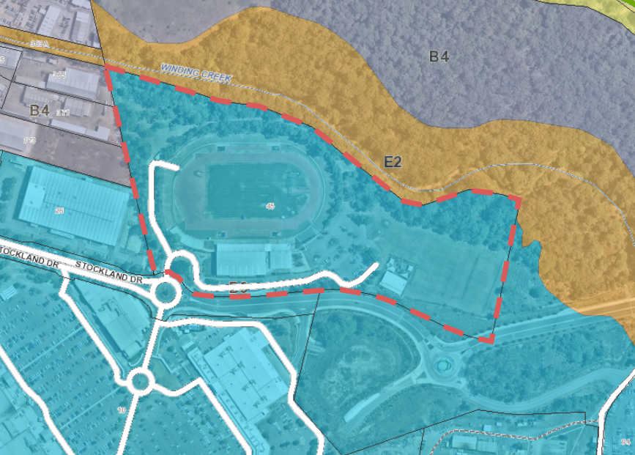

Figure - Map showing the site, surrounding land uses and zoning

**Proposal**

The application proposes expansion of the existing Hunter Regional Sports Centre including the following:

* health and fitness facilities (gymnasium);
* community facilities including function room and multi-purpose rooms;
* crèche;
* expanded gymnastics facility to include trampoline centre;
* expanded athletics facilities to include warm-up facilities;
* expanded car parking to service additional uses;
* expanded seating, amenities and ancillary facilities;
* landscaping;
* signage; and
* associated services.

Figures 2 shows the proposed site plan.

The development is proposed in two stages. Stage A will consist of the athletics warm up facilities, maintenance / grounds keeping building, community centre expansion and signalised pedestrian crossing. Stage B includes the trampoline centre. These stages may be undertaken in any order, however all car parking works shall be undertaken with whichever stage occurs first.

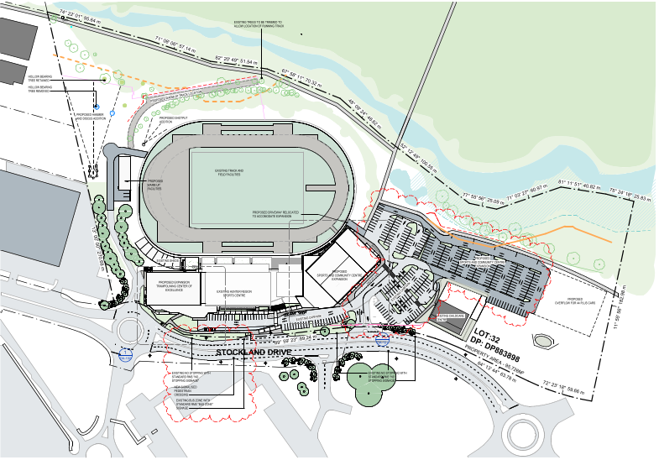

Figure - Site plan

**Detailed Assessment**

# Environmental Planning and Assessment Act 1979

Applicable State, Regional and Local Environmental Planning Instruments and Policies are detailed hereunder. Where not explicitly detailed, it is considered those instruments or policies are not relevant to the proposal.

# Section 4.15: Potential matters for consideration

## Section 4.15 (1) (a) (i) the provisions of any EPI’s

**State Environmental Planning Policy (State and Regional Development) 2011**

The proposal is identified as regionally significant development under the Schedule 7 of the SEPP due to Lake Macquarie Council being the owner of the land and the capital investment value of the development exceeding $5 million. The Hunter and Central Coast Regional Planning Panel will determine the development application.

**State Environmental Planning Policy No. 55 – Remediation of Land**

Clause 7 of the SEPP prevents the consent authority from granting consent to a development on land unless it has considered whether the land is contaminated and if the land is contaminated, whether it is suitable for the intended use with or without remediation.

The site was previously contaminated from activities associated with the NSW Railway workshops that previously occupied the land. Prior to construction of the existing Hunter Regional Sports Centre the site was subject to a comprehensive site contamination assessment and was subsequently remediated and validated as being suitable for its intended use. Property conditions relating to the site include a notation ‘Contamination Notation 4’ that is applied where land has been remediated and a Stage 4 validation report or site audit statement has been submitted confirming contaminants are below the contaminated land investigation threshold level as identified in the NEPM – Contaminated land for residential land uses.

The land is considered suitable for the development without remediation.

**State Environmental Planning Policy No. 64 – Advertising and Signage**

The SEPP applies to all signage that is visible from a public place. The development proposes an array of signage as detailed on Drawing DA-011, Revision K prepared by EJE Architecture encompassing business identification and wayfinding signage.

Clause 8 of the SEPP restricts a consent authority from granting consent to signage unless it is satisfied the signage is consistent with the objectives of the SEPP and satisfy the assessment criteria contained in Schedule 1.

Proposed signage is considered to be consistent with the aims of the SEPP contained in clause 3(1)(a). Signage will be of a professional quality and will not detract from the local amenity or visual character of the area. Signage is located in appropriate locations to identify the development and provide appropriate wayfinding throughout the site.

Signage is compliant with the assessment criteria contained in Schedule 1 that sets out requirements in relation to local character, impacts on sensitive lands, views, streetscape, impacts on building design, logos, illumination and safety. In particular:

* the site is located within a commercial centre that contains a significant amount of existing signage. The proposal will not detract from this signage or from the local character.
* signage is located on the southern side of the site throughout the car park and at the entry point. Signs will not affect environmentally sensitive land to the north of the site.
* signage will not be of a scale where it will impact on views or vistas, nor will signage on the site affect the viewing rights of other advertisers.
* signage is an appropriate scale and design and will not negatively affect the streetscape or protrude above the building or tree canopies.
* signage will be internally illuminated. Illumination is not likely to have any adverse impacts on local amenity given the location of the development within a commercial centre.
* the location and design of signage is unlikely to adversely affect safety of pedestrians or cyclists. Way finding signage within the car park will be above eye level and will not obstruct sightlines. Entry signage has a maximum height of 1200mm and will not obstruct sightlines.

The remaining clauses of the SEPP do not apply to the development.

**Lake Macquarie Local Environmental Plan 2014**

Part 2 – Permitted or prohibited development

The development is defined under LMLEP 2014 as *Recreation facility (outdoor and indoor)* and *Community facility*. Recreation facilities (indoor) and community facilities are permissible within the B3 Commercial Core zoning subject to development consent. Clause 11 of Schedule 1 ‘Additional permitted uses’ provides permissibility for the use of the site as a Recreation facility (outdoor).

The objectives of the B3 zone are:

* to provide a wide range of retail, business, office, entertainment, community and other suitable land uses that serve the needs of the local and wider community.
* to encourage appropriate employment opportunities in accessible locations.
* to maximise public transport patronage and encourage walking and cycling.
* to create urban centres and public spaces that are safe, accessible, welcoming and are a central focus for the community.
* to provide for housing as part of mixed use developments.

The proposal will build on the existing facilities offered at the Hunter Regional Sports Centre and is consistent with the above objectives.

Part 4 – Principle development standards

*Clause 4.3 Height of buildings*

The objectives of the building height are to ensure the height of buildings are appropriate for their location and to permit building heights that encourage high quality urban form.

A maximum building height of 13m applies to the land. The development is generally compliant with the building height restriction with the exception of two minor variations as follows:

* 0.745m exceedance applying to the trampoline centre, and
* 0.215m exceedance relating to the community centre.

A submission under clause 4.6 ‘Exceptions to development standards’ has been submitted in relation to the proposed height variations.

*Clause 4.6 Exceptions to development standards*

The objectives of clause 4.6 ‘Exceptions to development standards’ are to provide an appropriate degree of flexibility in applying development standards to achieve better outcomes than would otherwise be achieved through strict compliance.

Clause 4.6 is an appropriate mechanism to vary the maximum height limit set under clause 4.3 ‘Height of buildings’ of LMLEP 2014.

The applicant has submitted a written request under clause 4.6 to vary the 13m maximum height limit applying to the site. There are two portions of the development where minor exceedances occur including a 745mm (5.7%) exceedance for a portion of the trampoline centre roof and a 215mm (1.7%) exceedance for the upper eave of the community facilities building. The proposed exceedances are shown below.

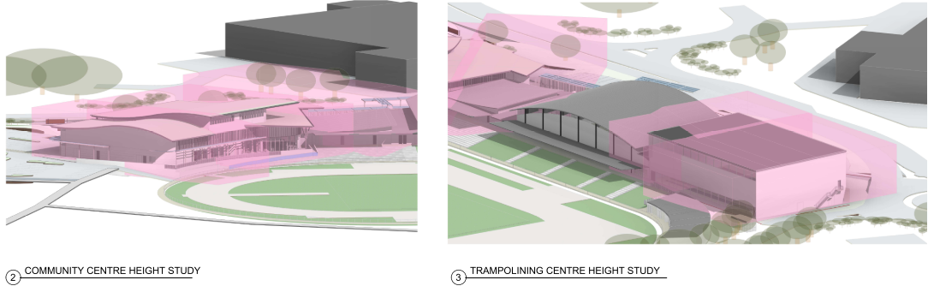

Figure - Height variations of proposed additions

Development consent must not be granted for development that contravenes a development standard unless the consent authority has considered a written request from the applicant that seeks to justify the contravention by demonstrating:

1. that compliance with the development standard is unreasonable or unnecessary in the circumstances of the case, and
2. that there are sufficient environmental planning grounds to justify contravening the development standard.

In response to justifying that compliance with the development standard is unreasonable or unnecessary in the circumstances of the case, the applicant refers to the principles set out by Chief Justice Preston in *Webhe v Pittwater Council [2007]*. In particular, it is argued the development achieves the objectives of the standard notwithstanding non-compliance with the standard and the underlying object or purpose would be defeated or thwarted if strict compliance was enforced. The following points are made:

* the height of the trampoline centre cannot be modified as it is required to achieve compliance with international standards in relation to floor to ceiling heights;
* the height is compatible and appropriate in scale to existing building forms. The existing building on the site displays a height greater than 13m;
* the design of new buildings are well considered and appropriate in terms of their architectural form achieving a high quality, high amenity and cohesive outcome for the site;
* achieving the desired inclusions for the community centre and adhering to the height restriction would result in a larger building footprint to the detriment of the site and surrounding areas;
* restricting development forms by strictly enforcing the development standard may be overly restrictive and may result in architectural outcomes unsuitable to the locality and existing development;
* The proposal has not disregarded the standard however looks for a level of flexibility tailored to the specific and unique development type.

In relation to establishing there are sufficient environmental planning grounds to justify contravening the development standard the applicant submits the following justification:

* the development meets the zone objectives and the height control objectives;
* the development is a continuation of an existing use and will provide significant improvement to internal and external amenity and provides additional services and facilities to new and existing users;
* the development is compatible with existing buildings within the complex and within the surrounding locality;
* the development does not result in unreasonable impacts.

Council considers the applicant’s clause 4.6 variation has provided sufficient justification that compliance with the development standard is unreasonable or unnecessary in the circumstances of the case, and there are sufficient environmental planning grounds to justify contravening the development standard.

In consideration of the clause 4.6 variation, Council have considered the development will be in the public interest because:

* it is consistent with the objectives of the building height standards; and
* is consistent with the objectives of the B3 Commercial Core.

Consideration also needs to be given to whether the variation raises any matter of significance for state or regional environmental planning, and the public benefit of maintaining the standard. There are no anticipated impacts on state or regional planning associated with supporting the proposal. The height exceedances are minor and located at the rear of the building. The variation to the maximum building height would not be perceivable to people viewing the development, nor is the proposed height out of context given the height of the existing building on the site. The development meets the objectives of the B3 zone as well as the objectives relating to building height within clause 4.3. The development provides high quality recreation and community facilities and will lead to positive social and economic outcomes. It is therefore considered there is no public benefit in maintaining the development standard in this instance.

As the consent authority for the development application, the Hunter and Central Coast Regional Planning Panel have delegation to determine the clause 4.6 variation.

Part 5 – Miscellaneous provisions

*Clause 5.10 Heritage conservation*

See discussion under clause 7.7 ‘Development on sensitive Aboriginal landscape areas’.

Part 7 – Additional local provisions

*Clause 7.2 Earthworks*

The development does not include any significant earthworks. The matters contained in subclause (3) have been considered in the assessment of the application. Minor earthworks proposed will not have a detrimental impact on the environment, neighbouring uses or cultural heritage.

*Clause 7.3 Flood planning*

The land is susceptible to flooding and is identified as a ‘flood planning area’. The development has been assessed against Council’s flood planning levels and is located above the site-specific minimum requirements for the area. No specific requirements apply to the proposal in relation to flooding.

*Clause 7.7 Development on sensitive Aboriginal landscape areas*

The site is identified as a sensitive Aboriginal landscape area. The applicant has submitted an Aboriginal Heritage Due Diligence Assessment in support of the application. The report does not identify any Aboriginal objects or areas of potential archaeological deposits in proximity to the development, and the area fits the definition of disturbed land as defined by the NSW Office of Environment and Heritage.

The application was referred to Aboriginal community groups for 28 days for consideration, with no submissions being received by Council at the close of this period.

There are no objections to the development on heritage grounds, however it is recommended a condition of consent be imposed identifying obligations to the developer should Aboriginal objects be discovered during construction.

*Cluse 7.21 Essential services*

The development has existing water, electricity and sewerage connections and no upgrade to facilities is required to accommodate the proposal. Adequate arrangements have been made for suitable stormwater drainage and vehicular access as set out within this report.

## Section 4.15 (1) (a) (ii) the provisions of any draft EPI

There are no draft EPI’s applicable to the development and/or site.

## Section 4.15 (1) (a) (iii) DCP’s

**Lake Macquarie Development Control Plan (DCP) 2014**

Part 4 – Development in business zones

*2 Context and setting*

*2.1 Site analysis*

A site analysis was undertaken by the applicant and submitted with the application. The development has been designed to respond to the constraints and opportunities of the site.

*2.2 Scenic values*

The site is identified within scenic management zone 13 (hinterland, high settlement) under the Lake Macquarie Scenic Management Guidelines 2013. The development does not trigger the requirement for a visual impact assessment and the proposal is not likely to have a negative impact on the scenic values of the area. Significant vegetation along the Stockland Drive frontage will be retained which provides screening to the existing and proposed development.

*2.3 Geotechnical*

The site is not identified as having any geotechnical restrictions.

*2.4 Cut and fill*

Building sections contained on drawing DA-300, revision N, dated 19/03/2020 prepared by EJE architecture show cut and fill up to approximately 1.5m within the building footprint. Levels for the car park extension are designed to respond to the existing site topography and will not be excessive. Earthworks will not affect adjoining properties and finished levels are designed to direct stormwater to the existing detention pond at the north of the car park.

*2.5 Mine subsidence*

The site falls within an identified mine subsidence district. The applicant sought approval for the development under section 22 of the Coal Mine Subsidence Compensation Act 2017. Conditional approval was granted 22 August 2019. Subsidence Advisory NSW conditions will be included in any consent issued.

*2.6 Contaminated land*

See discussion under SEPP 55 – Remediation of Land. The site is considered suitable for the intended purpose without remediation.

*2.7 Acid sulphate soils*

The site is not identified as being impacted by potential acid sulphate soils.

*2.8 Stormwater management*

The application is accompanied by a concept stormwater disposal plan that includes stormwater re-use, detention and water quality control generally in accordance with Council’s requirements. Council are satisfied the concept design can be accommodated within the site and not have adverse downstream impacts. Detailed calculations are to be provided prior to the issue of a construction certificate to inform the final design based on anticipated volumes. It is recommended this forms a condition of consent.

*2.9 Catchment flood management*

See discussion under LMLEP 2014 clause 7.3 ‘Flood planning’. The development is consistent with the applicable flood planning levels and no further restrictions apply.

*2.10 Lake flooding and tidal inundation (incorporating sea level rise)*

The property is not affected by lake flooding, tidal inundation or sea level rise.

*2.11 Natural water systems*

Winding Creek is located to the north of the site as shown in Figure 1. Winding Creek is identified as 3rd order watercourse and requires a 30m vegetated riparian buffer to be maintained. Works associated with the development are located outside of the 30m buffer. Stormwater quality control measures will be included in the detailed design to minimise nutrients and pollutants entering the waterway.

The application was referred to the Natural Resource Access Regulator under clause 91 of the Water Management Act 2000 for approval for works on waterfront land. NRAR advised in correspondence dated 8 October 2019 a controlled activity approval is not required.

*2.12 Bushfire*

The site is identified as bushfire prone land. The development is not a special fire protection purpose and approval under 100B of the Rural Fires Act 1997 is not required. A Bushfire Assessment Report has been submitted with the application providing an assessment of the proposal against the provisions of Planning for Bushfire Protection 2006. The report concludes the development is able to meet applicable requirements and makes recommendations in relation to asset protection zones, provision of electricity, water and gas services, internal roads, emergency management and landscaping. It is recommended these recommendations are included as conditions of consent.

*2.13 Flora and fauna and 2.14 Preservation of trees and vegetation*

The development proposes the clearing of approximately 0.28 hectares of native vegetation including three hollow bearing trees in the north-east portion of the site to accommodate the warm-up facilities and the workshop / services building. The loss of this vegetation has been addressed within the Biodiversity Assessment Report submitted with the application. This report has been reviewed by Council’ Ecologist who has advised the conclusions and recommendations of the report reasonably address local, State and Federal flora and fauna requirements including Council’s Flora and Fauna Assessment Guidelines and the Biodiversity Conservation Act 2016. No objections are raised to the application on ecological grounds.

All vegetation to be retained in proximity to the warm-up facilities and workshop / servicing building is to be clearly identified and fenced prior to works commencing and protected for the duration of the works.

The existing car park contains a number of mature or semi-mature trees. Many of the landscaped bays within the existing car park appear to be unaffected by the proposal and these trees should be able to be retained. It is recommended a condition of consent is included that requires an Arborist is engaged to undertake an assessment of existing trees within the car park and make recommendations in relation to the potential for retention.

The applicant’s Biodiversity Assessment Report recommends the vegetation retained at the north of the site be protected for conservation. It is recommended a restrictive covenant be registered over the property to this effect. The vegetation that the covenant relates to is shown in brown in Figure 4 below.

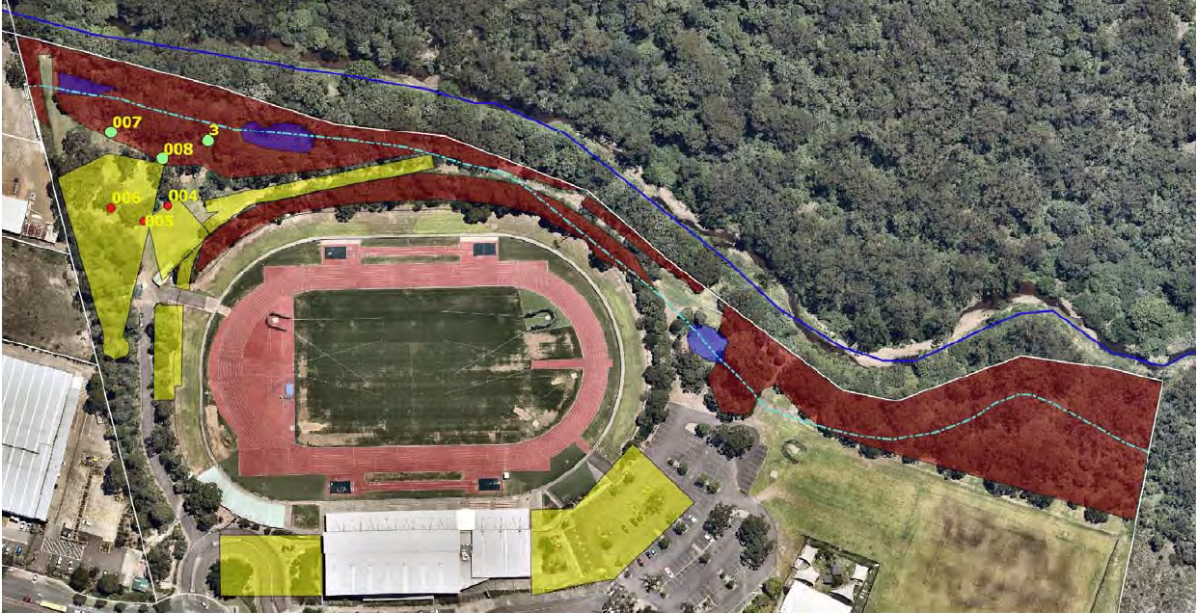

Figure - Land to be managed for conservation

*2.15 European heritage*

The site is not affected by any European heritage items.

*2.16 Aboriginal heritage*

See discussion under LMLEP 2014 clause 7.7 ‘Development on sensitive Aboriginal landscape areas’. No objections are raised on Aboriginal heritage grounds.

*2.17 Natural heritage*

No natural heritage items are identified in proximity to the development.

*2.18 Social impact*

The development is considered to have an overwhelmingly positive social impact providing a range of high-quality sporting and community facilities accessible to all sectors of the community.*2.19 Economic impact*

The development will contribute both short- and long-term economic benefits to the local area. These benefits include construction jobs, ongoing employment opportunities, public expenditure in the surrounding commercial precinct during events and tourism opportunities during major events.

*2.21 Utility infrastructure*

The site has current connections to all required utilities. Discussions will be held between the developer and the utility companies relating to any upgrade requirements.

*3 Streets and public space*

*3.4 Streetscape improvements*

Minor landscape works are proposed within the Stockland Drive road reserve to provide continuity with the existing landscaping in these areas. This is generally supported with the exception of the use of *Pyrus* species as street trees. A suitable replacement species can be conditioned. No additional street furniture or public art is deemed necessary.

Additional pedestrian linkages between the development site and the adjacent Stockland shopping centre will be provided. This will take the form of a signalised pedestrian crossing on Stockland Drive and will required approval from Transport for NSW.

*3.5 Non-discriminatory access*

The development is supported by a Disability Access Report prepared by Lindsay Perry Access. The consultant certifies the development as submitted generally complies with the Building Code of Australia 2016 and the intent of the Disability Discrimination Act 1992. Compliance will be addressed within the detailed design drawings submitted for the Construction Certificate. It is recommended these drawings are certified by the Access Consultant.

*3.6 Lighting*

Lighting is proposed throughout the site including around the warm-up facilities and throughout the car park. A detailed lighting plan has not been prepared. It is recommended a condition of consent is imposed requiring a lighting plan to be prepared and approved by Council prior to the issue of a Construction Certificate.

*4 Active street frontage*

The following controls are not directly applicable to the development as they generally cater for traditional commercial or retail development. Some general comments are provided below.

*4.2 Ground floor levels*

Floor levels have been designed to integrate with the existing gymnastics building on the site which is retained in the design of the development.

*4.3 Ground floor entries*

The development incorporates clearly identifiable entry points to the building in addition to extensive wayfinding signage meeting the design objectives.

*4.4 Ground floor glazing*

This is not directly applicable to the development as the building is set back from the street and internal uses are not conducive to widespread glazing. Glazing is provided around entry points to provide clear visual connections between the building and the car park.

*4.5 Street awnings*

The development is set back from the street and therefore does not provide street awnings. The development does provide awnings along the front of the building which is connected to a covered walkway linking the building to the adjacent public bus stop on Stockland Drive. This provides suitable shade and weather protection in pedestrian priority areas.

*5 Access and parking*

5.1 *Traffic and vehicle access*

The vehicular entry point for the public is relocated under this proposal from its existing position at the round-a-bout to a point approximately 70m to the east closer to the car park area. This will be a ‘left in, left out’ access due to the existing central median in Stockland Drive. Service vehicles will continue to utilise the entry at the round-a-bout.

A Traffic Assessment Report and subsequent Intersection Assessment Report have been prepared by B J Bradley & Associates in support of the development. Whilst initial concern was raised by Council in relation to the ability for the existing round-a-bout to cater for the additional traffic generated by the development, SIDRA analysis has demonstrated the round-a-bout will perform satisfactorily with a 500% increase in traffic modelled to represent a worst case scenario. Traffic generation and vehicular access proposed under this development are therefore considered satisfactory.

*5.2 Design of Parking and service areas*

The proposal seeks to retain a component of the existing car park and provide additional spaces to the east to offset those spaces lost due to the building layout and to support the additional usage and capacity of the facility. Swept paths have been provided for buses and service vehicles accessing the site. The layout of the car park complies with applicable Australian Standards and is supported.

*5.3 Bike parking and facilities*

Bicycle racks are proposed at the eastern end of the building and adjacent to the existing undercover walkway leading to the bus stop. The development incorporates adequate shower and changing room facilities to accommodate cyclists. DCP rates require bicycle parking to be provided at a rate of 10% of required car parking spaces. Accordingly, bicycle parking for 31 bicycles is required. It is recommended this be included as a condition of consent.

*5.4 Motor bike parking*

The development provides designates motorbike parking for 22 vehicles. This meets DCP requirements that require 1 motorbike space per 20 car parking spaces.

*5.5 Car parking rates*

The existing development includes a parking provision of 214 spaces. The proposed development will include the provision of 308 formal car parking spaces as well as capacity for overflow parking catering for an additional 60 vehicles.

A parking assessment undertaken by B J Bradley & Associates identifies that in excess of 1000 parking spaces would be required to meet the peak parking demand at the site during major events. It is not economically feasible or practical to provide this level of car parking that will remain underutilised for much of the time. The report recommends 368 spaces in additional to the proposed bus parking is sufficient to cater for the general use of the development, noting the facility will be managed to prevent major events coinciding.

New time limited car parking spaces will be provided to service the existing childcare centre operating from the site. A total of seven 30-minute parking bays and three 15-minute parking bays are provided adjacent to the childcare entrance. This is a continuation of the existing arrangements and contributes to the overall parking allocation on site.

Parking provision is considered to be acceptable for the intended uses.

*6 Development design*

*6.2 Front setbacks – main street shops in B1, B2 and B3 zones*

Although located within the B3 zone, the development controls are not directly applicable to the proposal due to the nature of the development. The DCP stipulates building to the street boundary, in this case Stockland Drive, to maximise building mass and floor space at the street boundary. These controls generally relate to traditional commercial or retail development on main streets. The layout and general character of existing development in the locality does not set a defined setback or theme. Development is dominated by the Stockland shopping centre that provides retail premises surrounding a large central car park and does not address Stockland Drive in any meaningful way.

The development extends the existing building on the site and results in the south-eastern corner of the trampoline centre being positioned approximately 2.5m from the boundary. As the building extends to the west, the setback increases significantly. No objections are raised to this setback given the existing development patterns and absence of any significant adverse impacts.

*6.5 Building exteriors*

Perspectives of the development are provided in drawing no. DA-041 and DA-042, revision K, prepared by EJE Architecture. The development incorporates adequate façade articulation and a variety of colours that successfully offset building bulk.

*6.7 Side and rear setbacks*

This control is not directly applicable to the development. The DCP allows development to be built to the side boundary. At its closet point, the proposal maintains a 20m setback to the western boundary, whilst significant setbacks are maintained to the eastern side boundary and rear boundary. Proposed setbacks are considered acceptable.

*6.9 Building depth*

All areas within the development are within 15m of an adequate natural light source as per DCP requirements.

*6.12 Building height*

See discussion under LMLEP 2014 clause 4.6 ‘Exception to development standards’. Minor exceedances are proposed to the 13m maximum building height applicable to the site. The variation is considered worthy of support.

*6.14 Floor to ceiling heights*

The development incorporates generous floor to ceiling heights in excess of the minimum requirements set out under the DCP.

*6.15 Roofs*

The design incorporates a variety of roofing including low pitched skillion and curved roof forms. A solar installation is shown on the trampoline centre roof which will not be visually obtrusive.

*6.16 Views*

The development does not impede views.

*6.20 Energy efficiency and generation*

The design of the development allows for natural ventilation and passive solar access to internal areas. Solar panels are proposed to offset energy usage within the development.

*6.22 Acoustic privacy*

There are no acoustic privacy concerns affecting the development.

*6.23 Front fences*

No front fencing is proposed.

*6.24 Side and rear fences*

No side or rear fencing is proposed.

*6.25 Safety and security*

A Crime Risk Report prepared by deWitt Consulting has been submitted to support the development. The report identifies a number of strategies to mitigate risk and to ensure the proposed development is designed / constructed in accordance with CPTED principles. Council officers concur with the measures identified in the report regarding surveillance, access control, territorial reinforcement, activity and space management, building design, lighting, access, car parking, fencing and landscaping that have been integrated into the design. Several recommendations in relation to surveillance, landscaping, maintenance and wayfindingare made to further increase the safety and security of the development. It is recommended conditions of consent are imposed requiring reflecting these recommendations.

*7 Landscape*

*7.1 Landscape Design*

Terras Landscape Architects have prepared adequate landscape documentation supporting the development.

*7.2 Street tree and streetscape improvements*

Proposed streetscape works are supported with the exception of supplementary planting of *Pyrus* species as street trees. Planting of native non-deciduous trees is recommended and this has been discussed with the consulting Landscape Architect. It is recommended conditions of consent include species to be planted within the road reserve.

*7.3 Landscape and tree planting in front setback areas*

Much of the front setback is occupied by existing car parking areas and there is limited opportunity for additional landscaping in these areas. The existing landscape buffer along Stockland Drive will be embellished with additional plantings as demonstrated in the landscape plan submitted with the application.

*7.4 Landscape and tree planting in car parks*

Tree planting throughout the car park as proposed within the landscaping documentation has been reviewed by Council’s Landscape Architect and is supported. Engineering plans show tree planting areas equal to a parking bay width and this is supported as it represents a viable tree pit.

The proposed diversion trench along the northern side of carpark is to be stabilised and planted out with native ground covers. No turf is supported in this area. It is recommended this is included as a condition of consent.

*8 Operational requirements*

*8.1 Demolition and construction waste management*

A demolition and construction waste management plan has not been prepared. A condition of consent is recommended requiring a waste management plan be prepared in accordance with the 2019 Lake Macquarie Waste Management Guidelines and submitted and approved prior to the issue of a Construction Certificate.

*8.2 Operational waste management*

An adequate operational waste management plan has been submitted. Waste will be transferred via trailer to the waste storage area proposed on the western side of the site near the proposed athletics warm up facilities. Waste streams are collected weekly from this location.

*8.4 Liquid trade waste and chemical storage*

The development includes areas for storage of oils that are currently collected every three months. No change is proposed to this arrangement.

A condition of consent is recommended requiring the operator of the café/commercial kitchen to obtain a trade waste agreement with Hunter Water if required.

*8.5 Erosion and sediment control*

An adequate erosion and sediment control plan prepared by Northrop Consulting Engineers has been submitted in support of the proposal.

Part 9.17 – Signage

*17.1 Design*

The development proposes an array of signs as detailed on Drawing DA-011, Revision K prepared by EJE Architecture encompassing business identification and wayfinding signage. The design of signage proposed in conjunction with the development positively integrates with the building design and will not detract from the streetscape.

*17.2 Positioning*

The positioning of signage will not obstruct sightlines, result in visual clutter or obstruct operations on the site. A signage theme has been adopted for the development resulting in a cohesive design appearance. Wayfinding signage is proposed throughout the development to assist in directing visitors to appropriate locations. Business identification signage is proposed for both the existing childcare centre and the Hunter Regional Sports Centre. One of these signs will be positioned adjacent to the bus stop on Stockland Drive while others will be adjacent to the building.

*17.3 Specific sign dimensions*

All proposed signage is freestanding. Dimensions of the propose wayfinding signage has been provided and is considered acceptable. No dimensions are provided for the three business identification signs which will be the most prominent signage at the site. The DCP allows for a height up to 6m and width of 3.5m. It is recommended a condition of consent be included requiring dimensions to be submitted for these signs and approval to be granted by Council prior to the issue of a Construction Certificate.

*17.4 Illuminated, flashing and moving signs*

Signage will be internally illuminated. Illumination is not likely to have any adverse impacts on local amenity given the location of the development within a commercial centre.

Part 10.8 – Glendale Regional Centre

*2 Regional Centre Development Controls*

*2.6 Streetscape and Landscaping*

See discussion under DCP 2014, Part 4, section 7 Landscape. Landscaping proposed for the site is generally supported subject to an alteration in tree species.

*3 Precinct plans*

The site falls within Precinct C.

*6 Precinct C*

*6.1 Precinct Plan*

The development is generally consistent with the Precinct Plan developed for the site as depicted in Figure 5. The main entry to the site has been relocated from the round-a-bout approximately 70m to the east. The access at the round-a-bout, whilst not retained as a major access, will be retained for service vehicles and access to the athletics warm up facilities.

Provision has been made for the future provision of a shared pathway connecting land to the north to the site.

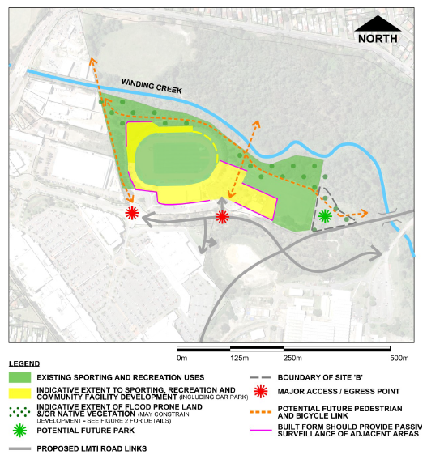

Figure - Precinct C plan

## Section 4.15 (1) (a) (iv) any matters prescribed by the regulations

The application proposes minor demolition works to allow the development. Conditions of consent are recommended to ensure these works are undertaken in accordance with relevant standards.

## Section 4.15 (1) (b) the likely impacts of the development

#### The likely impacts of the development contained in this part of the Act have been detailed throughout the assessment report.

## Section 4.15 (1) (c) the suitability of the site for development

#### Does the proposal fit the locality?

It is considered the development fits the locality. The site is currently occupied by the Hunter Regional Sports Centre. The development seeks to expand the facilities offered at the site and has been identified for the intended purpose under Council’s strategic planning documents. The site is well located in relation to services and public transport and is compatible with the adjacent retail development.

#### Are the site attributes conducive to development?

As demonstrated in this report, the site is conducive to the development proposed.

## Section 4.15 (1) (d) any submissions made in accordance with this Act or the Regulations?

#### Public submissions:

There were no submissions received in relation to the development

## Section 4.15 (1) (e) the public interest

The proposed development is considered to be in the public interest. The application provides a development that is consistent with the zoning of the land and is not expected to have an adverse impact on the locality.

Further, the development provides high quality public facilities which provide social and economic benefits to the wider community.

The application has demonstrated compliance with relevant controls, and where variations exist, has demonstrated that no significant amenity impacts will arise now or in the future, subject to the imposition and compliance with recommended conditions of consent. This includes a submission under Clause 4.6 ‘Exceptions to development standards’ in relation to the maximum height limit applicable to the site.

## Section 7.12 Fixed development contribution levies

The application was referred to Council’s Local Development Contributions Officers. Contributions will not apply to this application as under s7.12 (2019) contributions do not apply to Council owned land.

**Endorsement**

The staff responsible for the preparation of the report, recommendation or advice to any person with delegated authority to deal with the application has no pecuniary interest to disclose in respect of the application.

The staff responsible authorised to assess and review the application have no pecuniary interest to disclose in respect of the application.



Anna Kleinmeulman

Senior Development Planner

Development Assessment and Certification

**Date 22 April 2020**

I have reviewed this report and concur with the recommendation.



Amy Regado

Chief Development Planner

Development Assessment and Certification